- Compute the no. of days remaining in this year.

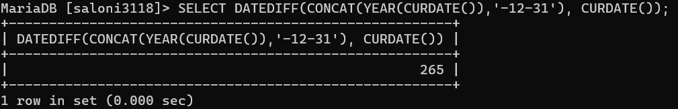

- Find the highest and lowest salaries and the difference between of them.

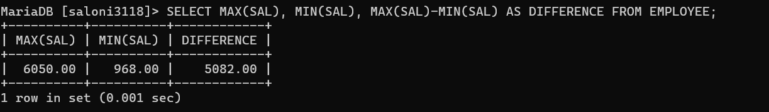

- List employee whose commission is greater than 25 % of their salaries.

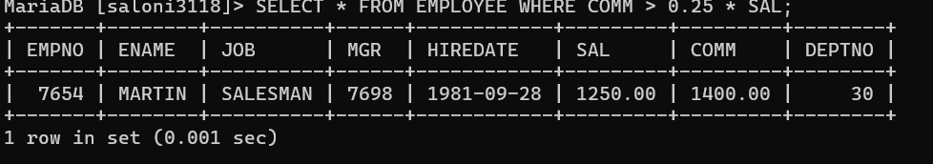

- Make a query that displays salary in dollar format.

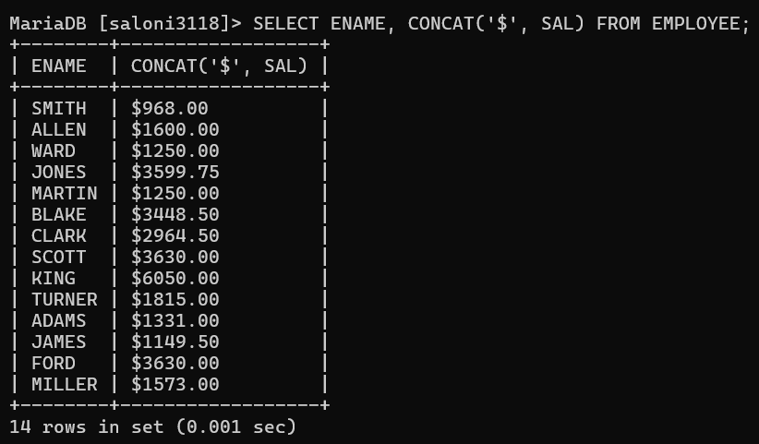

- Create a matrix query to display the job, the salary for that job based on

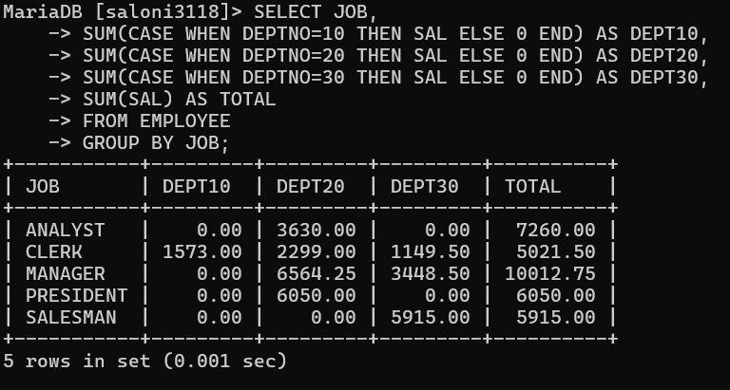

- department number, and the total salary for that job for all departments, giving each column an appropriate heading.

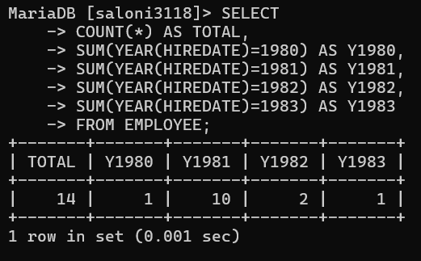

- Query that will display the total no of employees, and of that total the number who were hired in 1980,1981,1982 and 1983. Give appropriate column heading.
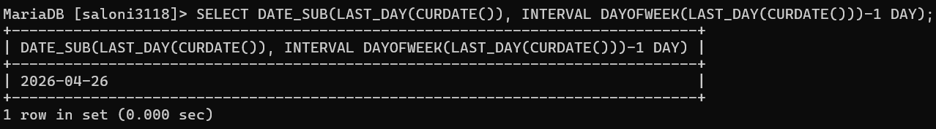

- Query to get the last Sunday of Any Month.
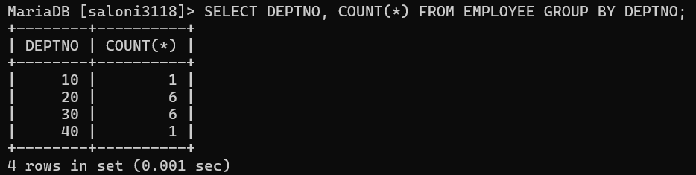

- Display department numbers and total number of employees working in each department.
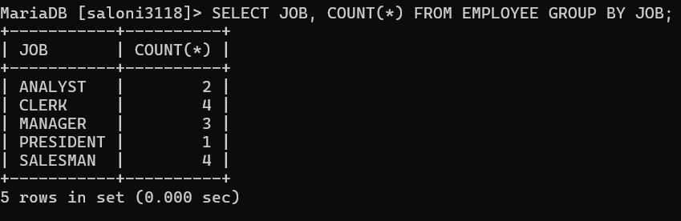

- Display the various jobs and total number of employees within each job group
